**Worksheet – 1.3**

**Student Name:** Vivek Kumar  **UID:** 21BCS8129

**Branch:** BE-CSE (LEET) **Section/Group:** 809/A

**Semester:** 4th **Date of Performance:** 28/03/2022

**Subject Name:** Computer Network Lab **Subject Code:** 20CSP-257

**1. Aim/Overview of the practical:**

Create a network connection using packet tracer, which shows the working of Switch and Hub. Explain in detail with proper steps.

**2. Task to be done/ Which logistics used:**

* Implementation of Switch
* Implementation of HUB

**Prerequisites:**

**S/W:**

* Laptop/Desktop
* CISCO Packet Tracer program

**H/W:**

* Main Memory - 128 MB RAM
* Hard Disk – minimum 20 GB IDE Hard Disk
* 44 MB Floppy Disk Drive
* –52X IDE CD-ROM Drive
* PS/2 HCL

**3. Steps for experiment/Code with Result/Output:**

**Setting Up:**

Follow the below steps to initiate the setup for the connection:

**Step 1:** Download Cisco Packet Tracer.

**Step 2:** Run and install the setup (You can be requested to log in to your Cisco Networking Academy Account or you can also log in as a guest).

**Step 3:** After the installation procedure has completed this display (below) will appear when you run the Cisco Packet Tracer-Start the application.

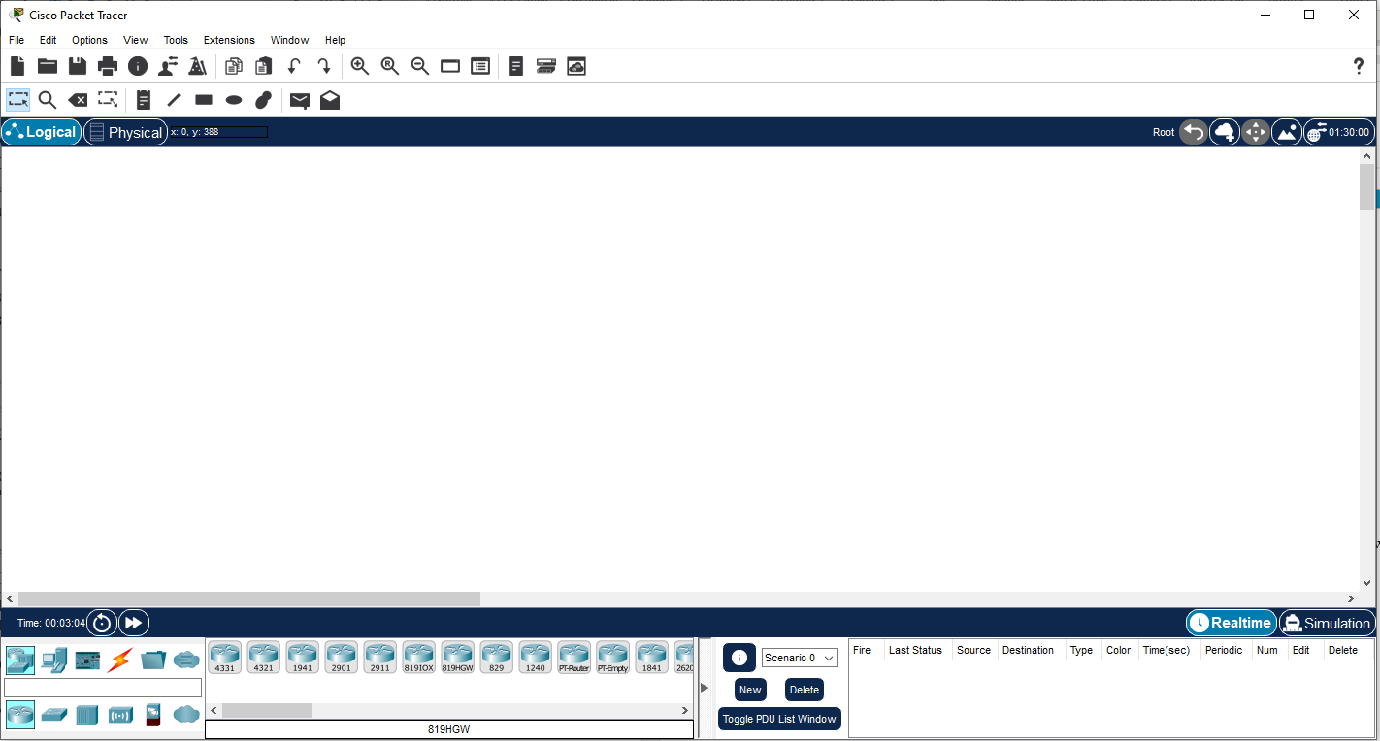

Cisco Packet Tracer

**Implementation of Switch:**

**Follow the below steps to implement the connection:**

**Step 1:** From the bottom toolbar, click on **‘End Devices’** and select **‘PC’** and then click on the screen (for three PC’s do this step trice).

Bottom toolbar->End devices->PC

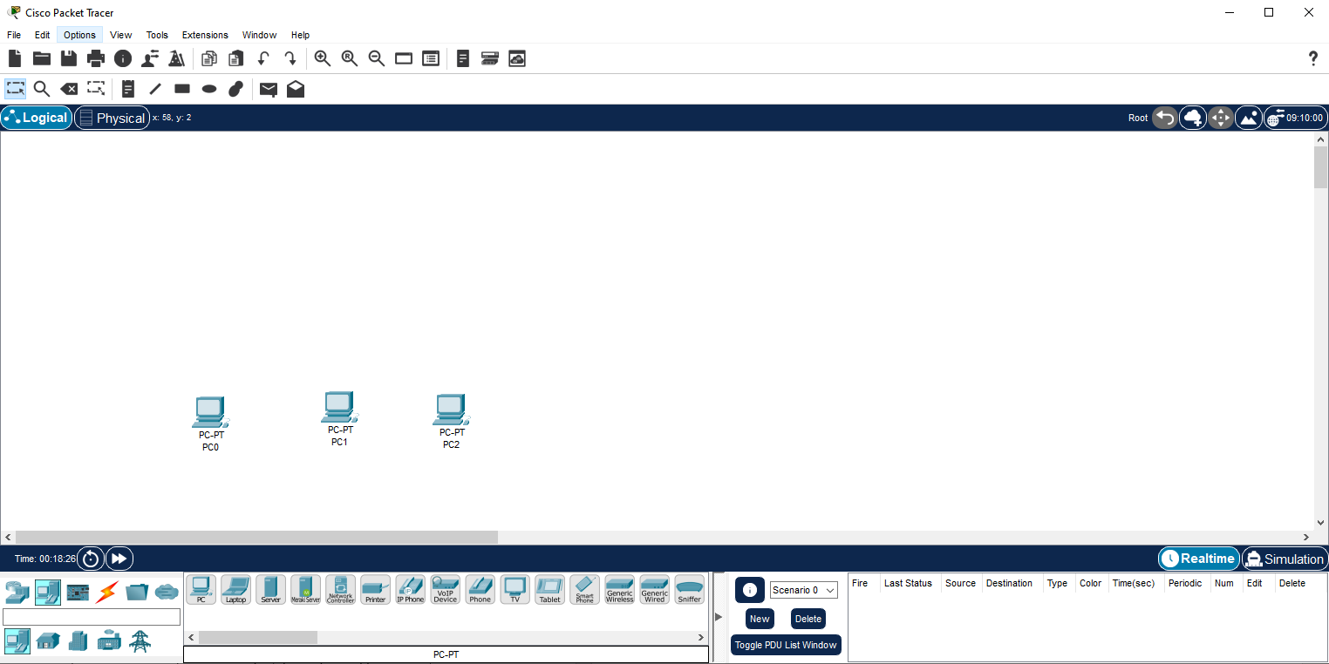

**Step 2:** Now to select the Network devices from bottom bar select the switch and then select the Switch-PT and then click on the screen.

Bottom toolbar-> Network devices ->Switch -> Switch-PT

This is how it will appear on the screen

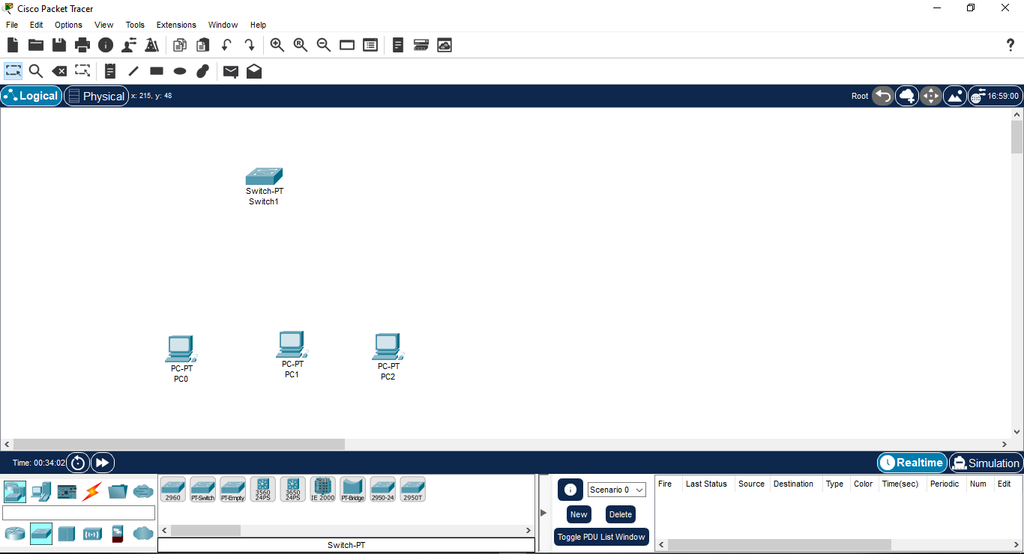

**Step 3:** Now to select the Connections from bottom bar and select the Couper Straight-Through wire.

Bottom toolbar-> Connections -> Couper Straight-Through

This is how it will appear on the screen

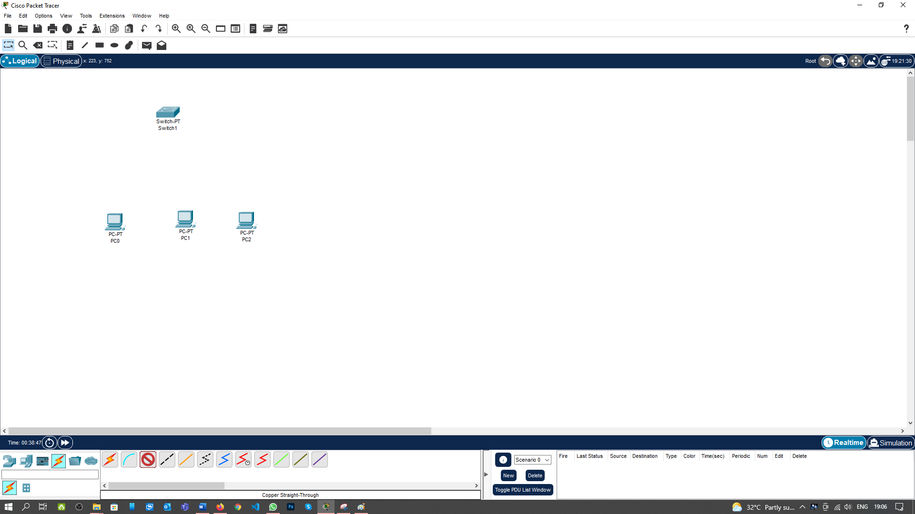

**Step 4:** Now to select the PC 0 you will get the Popup for the port then select the FastEthernet0.

Select PC 0 -> FastEthernet0

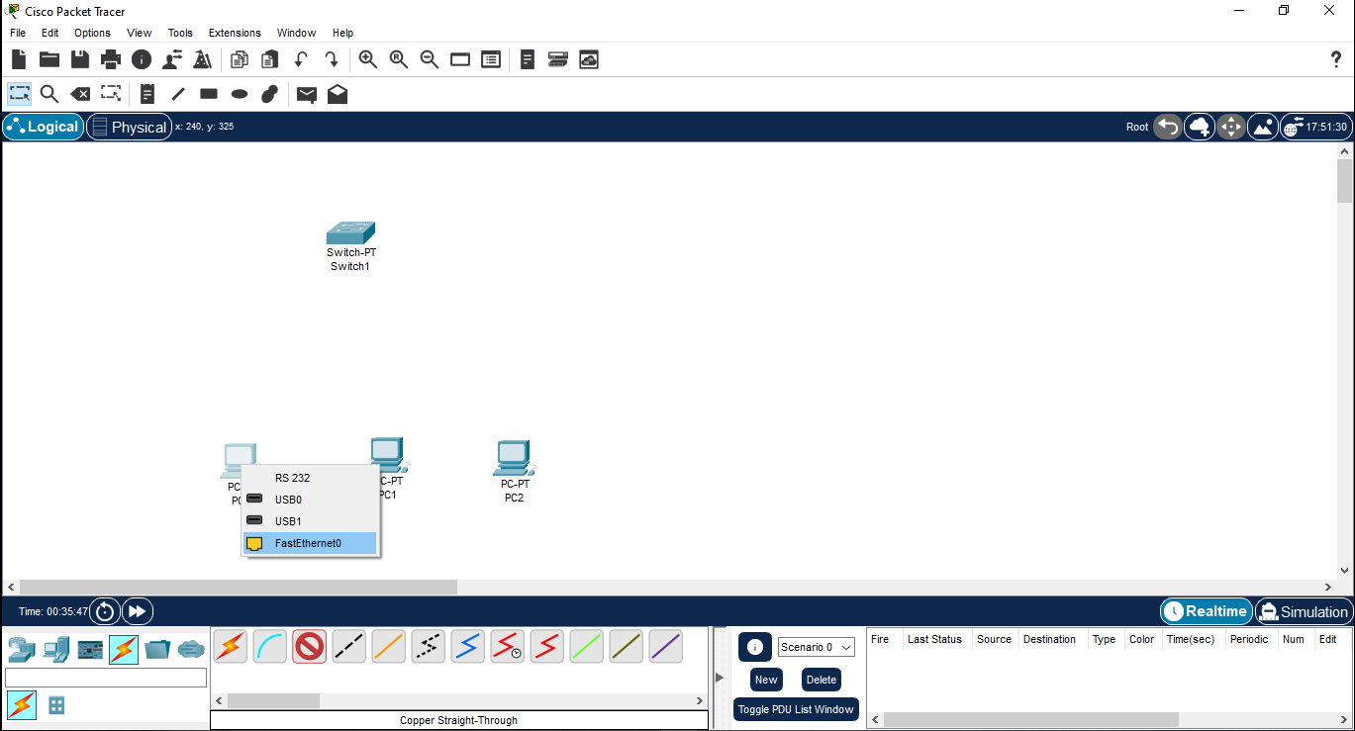

**Step 5:** Now click on the Switch you will get the Popup for the port then select the FastEthernet0/1 or Available Fast Ethernet port.

Select Switch -> FastEthernet0/1

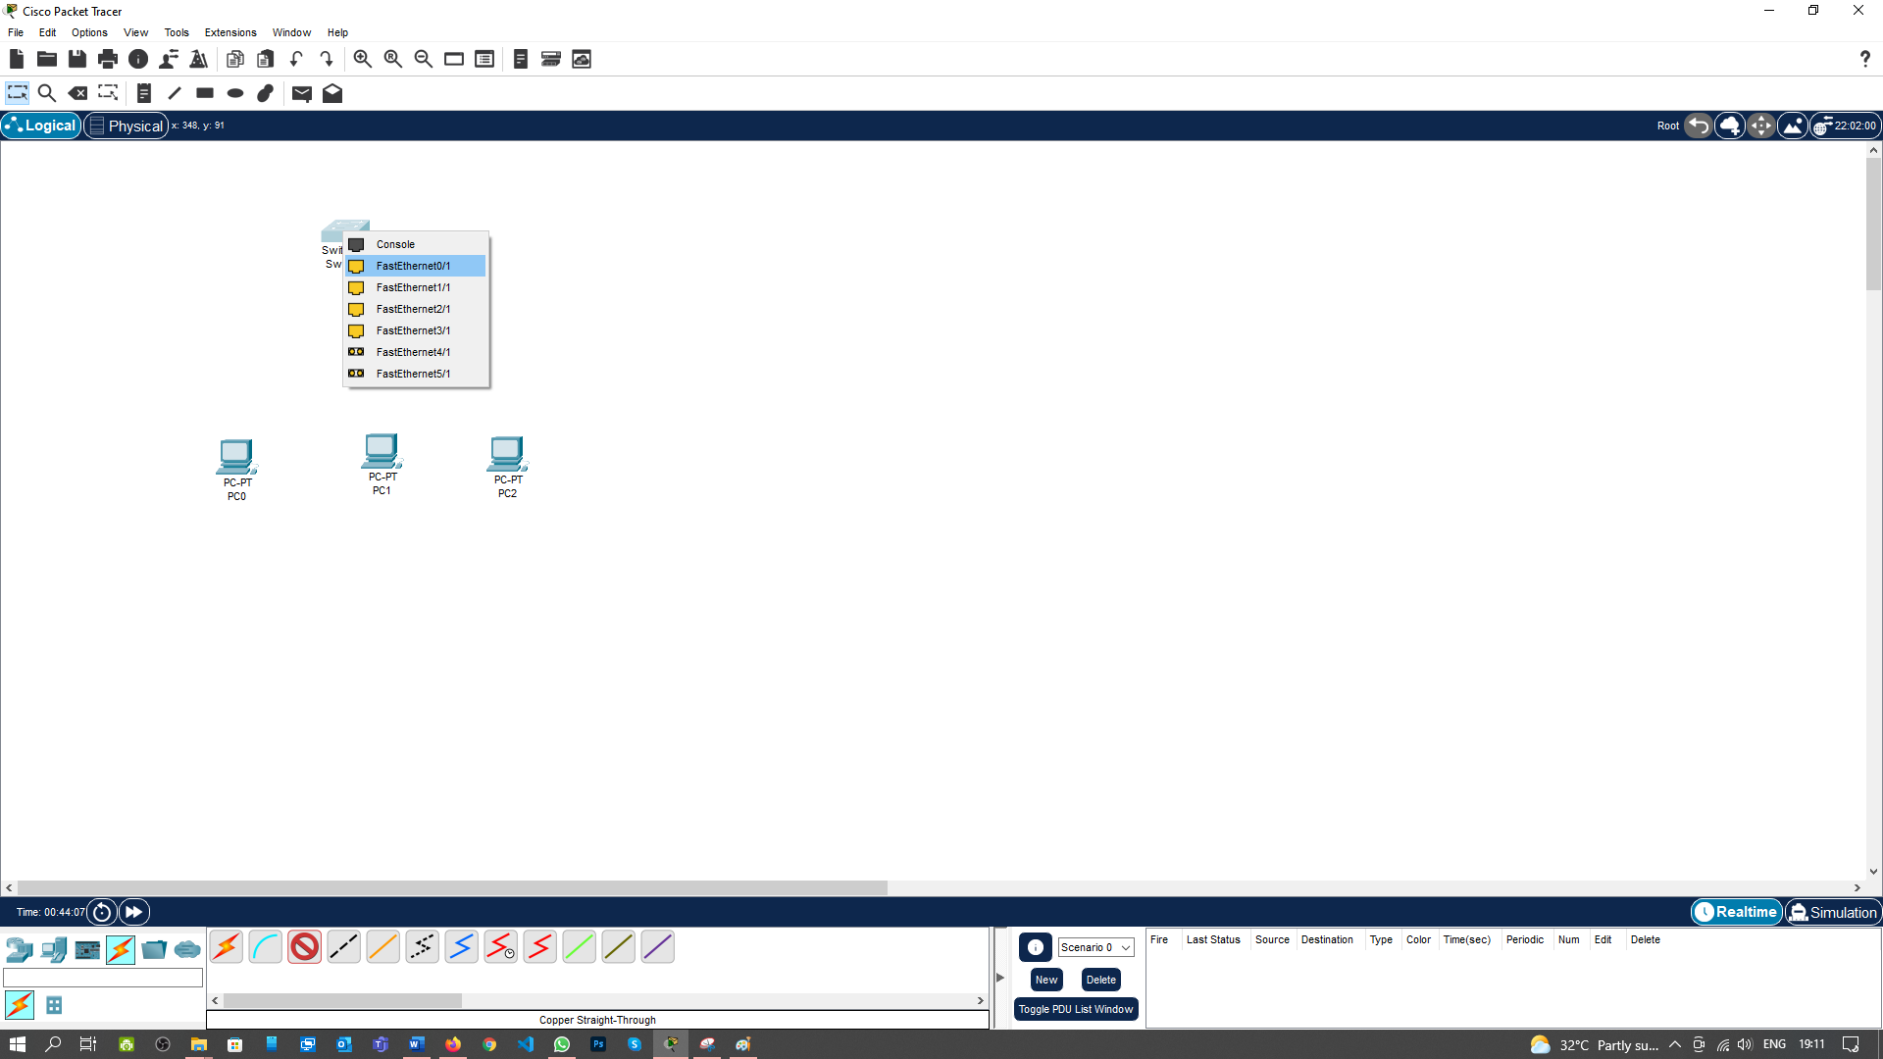

Now the Screen will be appeared Like this

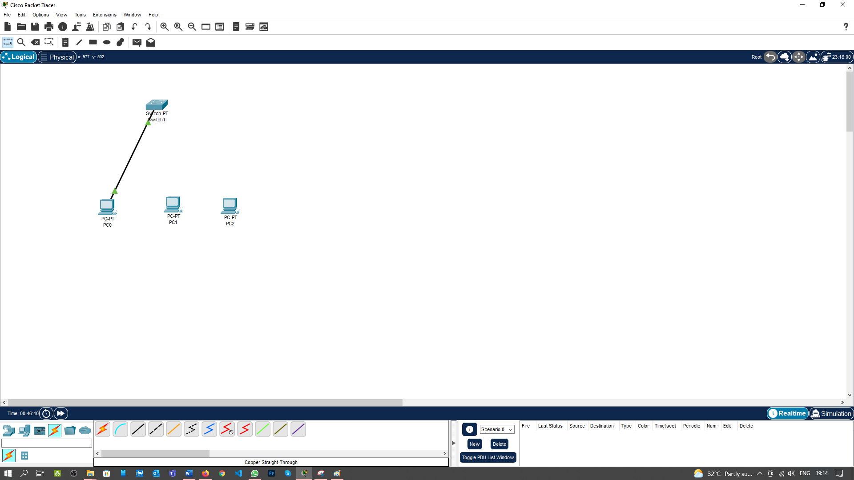

**Step 6:** Repeat the step 3 to 5 for all the PC1 and PC2

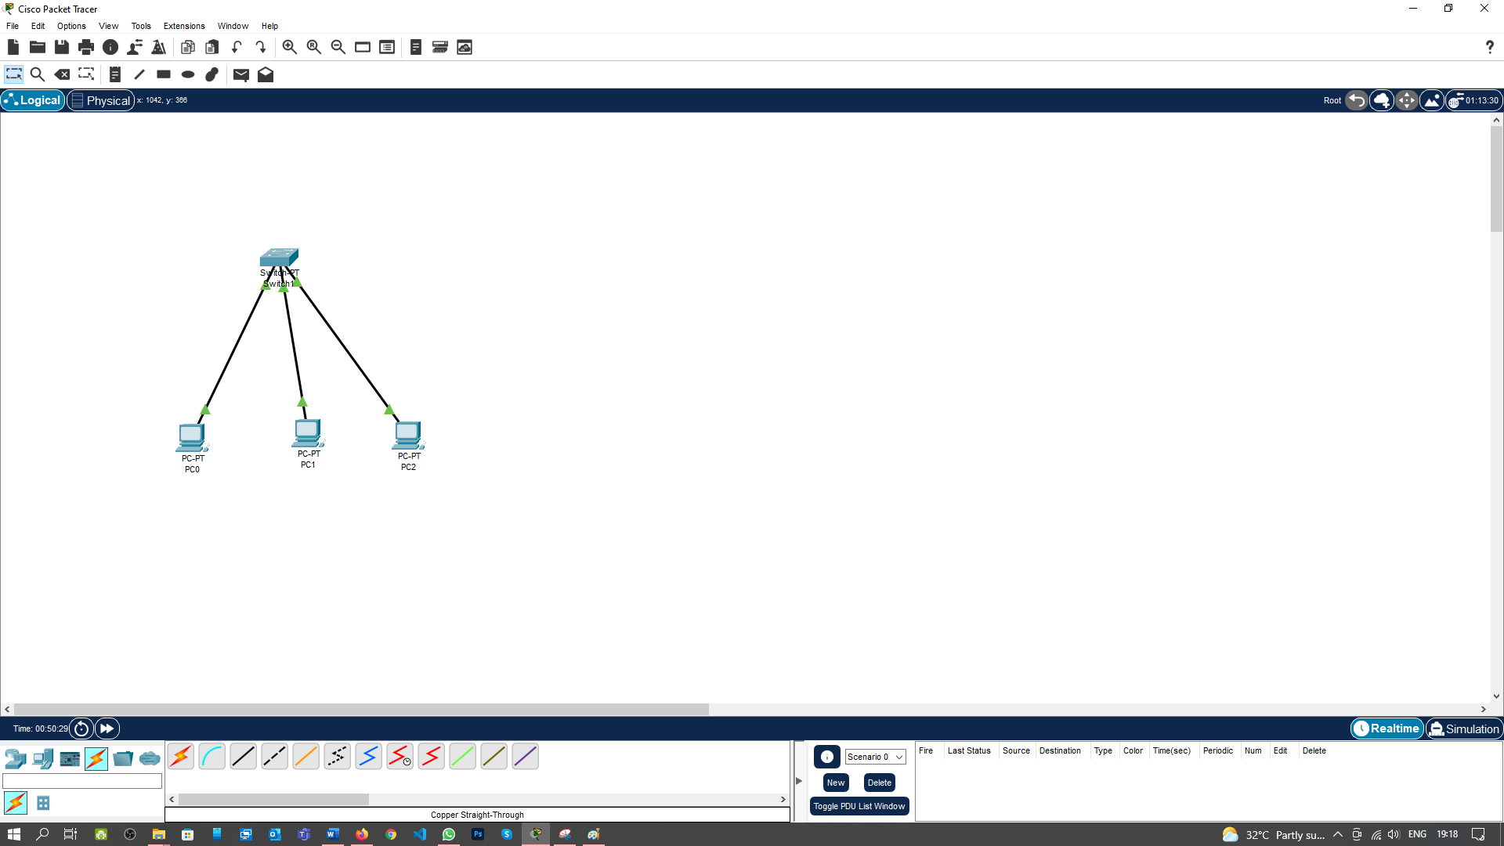

**Now, we will assign the IP address to all three PCs (PC0, PC1 & PC2).**

**Step 7: Click on the PC0 then on new window will open for Configuring the PCs.**

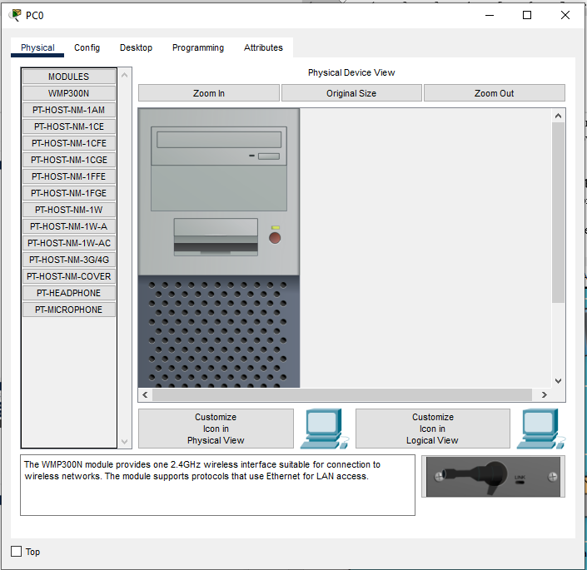

**Step 8:** Select the Desktop.

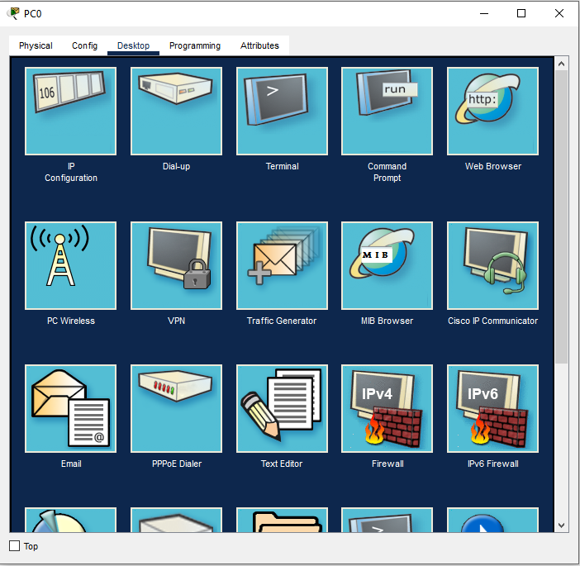

**Step 9:** Select the IP Configuration.

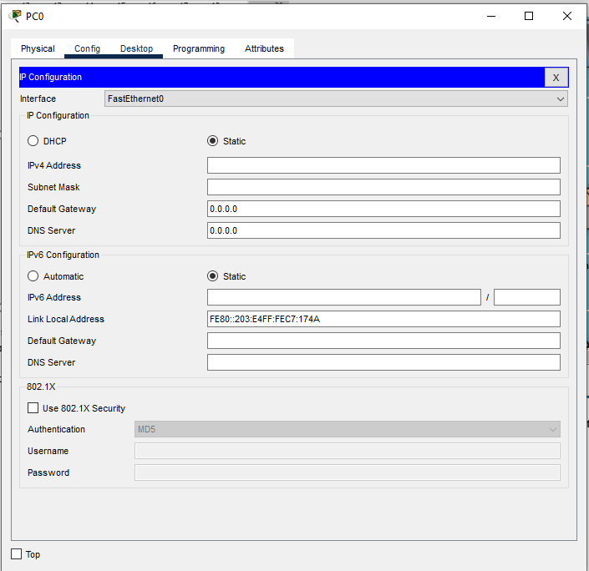

**Step 10:** Type the IP Address 192.168.1.1 and click on the Subnet Mask fields. It will accept automatically.

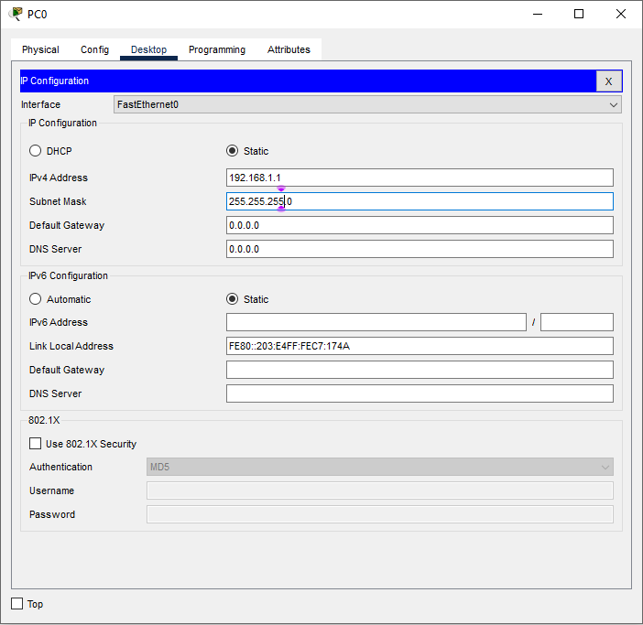

**Step 11:** Repeat the Step 7 to Step 10 for PC1 & PC2 with the IP Address 192.168.1.2 & 192.168.1.3 respectively.

**Now our all the Connection is done for Communication Using Switch.**

**Step 12:** To check the connection of the PCs Just Go to the Desktop and Click on the Command prompt of the PC0 and type the Ping Command along with the IP Address of PC2.

Click on PC0->Desktop->Command Prompt

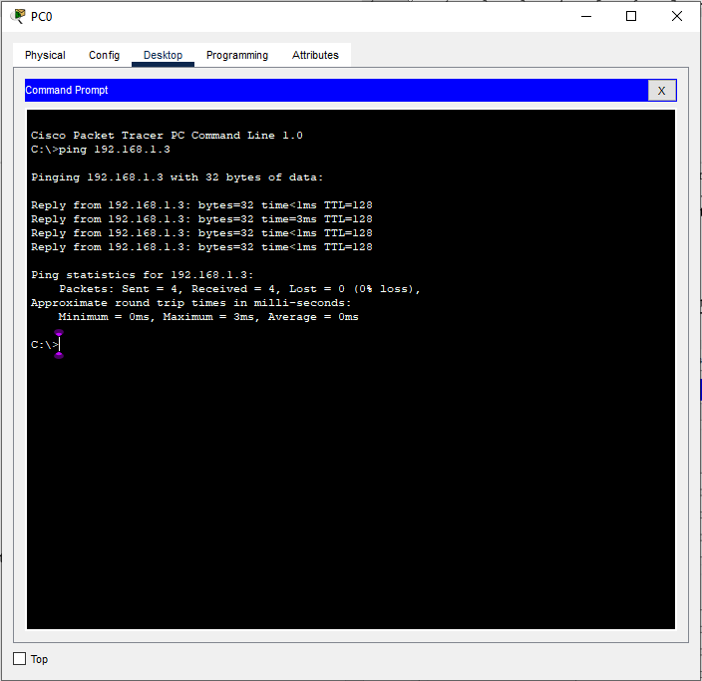

**Step 13:** Select the **Add Simple PDU** from the Task bar and Then selct the PC0 first then Select the PC2 you will see the **RunTime**  Successful message uin The Bottom bar.

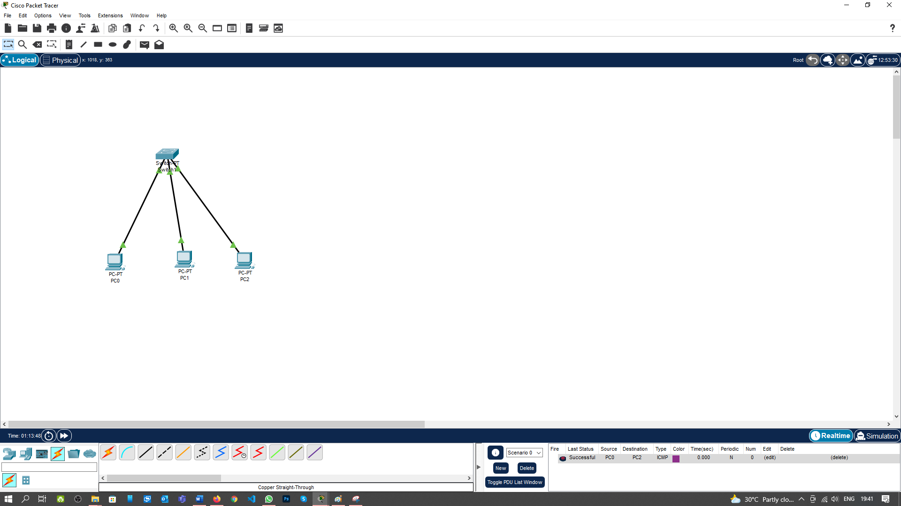

**Step 13:** Now select the Simulation Mode from the Bottom Bar and then Click Paly.You will Absorb the Steps of message transfer from PC0 to PC2 which is shown in the Below Screenshot.

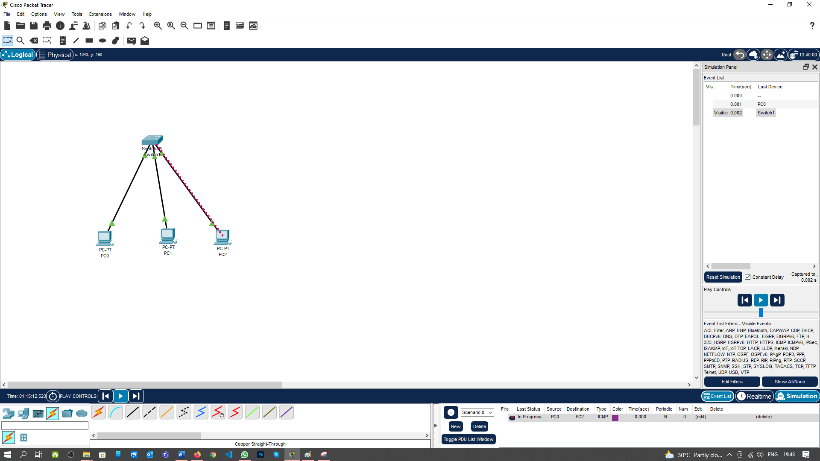

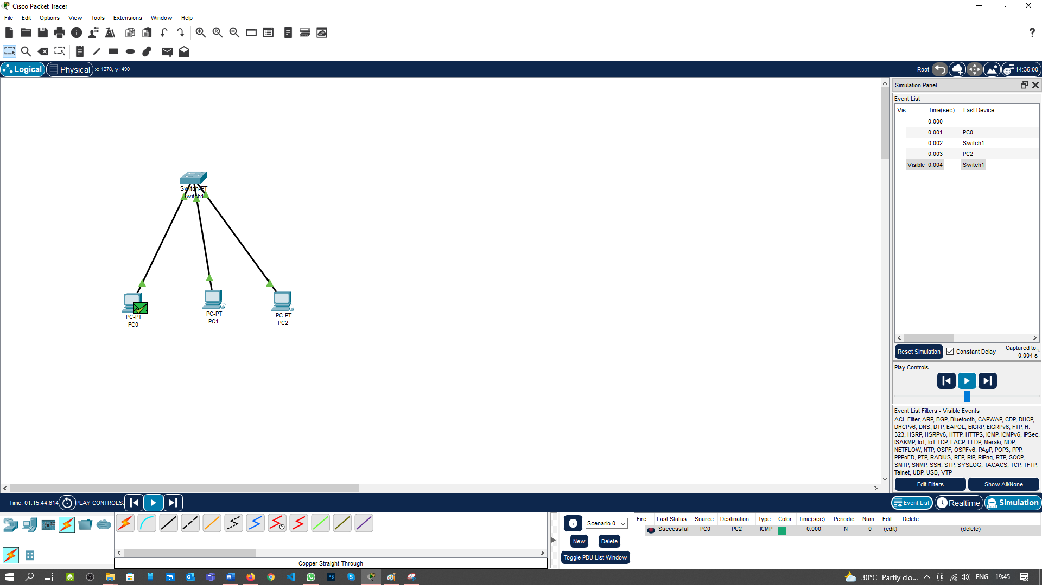

**Implementation of Hub:**

**Follow the below steps to implement the connection:**

**Step 1:** From the bottom toolbar, click on **‘End Devices’** and select **‘PC’** and then click on the screen (for three PC’s do this step trice).

Bottom toolbar->End devices->PC



**Step 2:** Now to select the Network devices from bottom bar select the switch and then select the PT-Hub and then click on the screen.

Bottom toolbar-> Network devices ->Hub -> PT-Hub

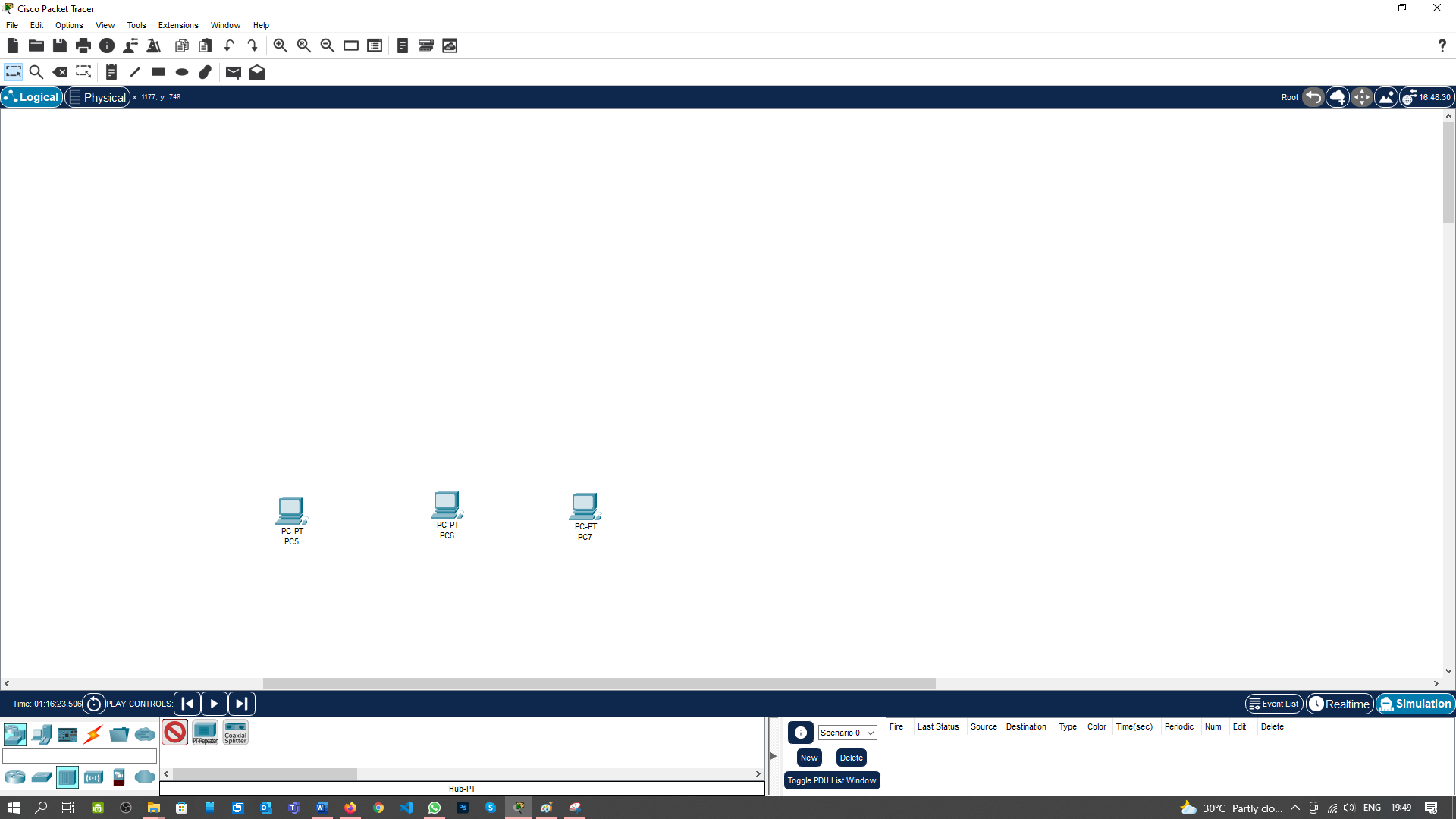

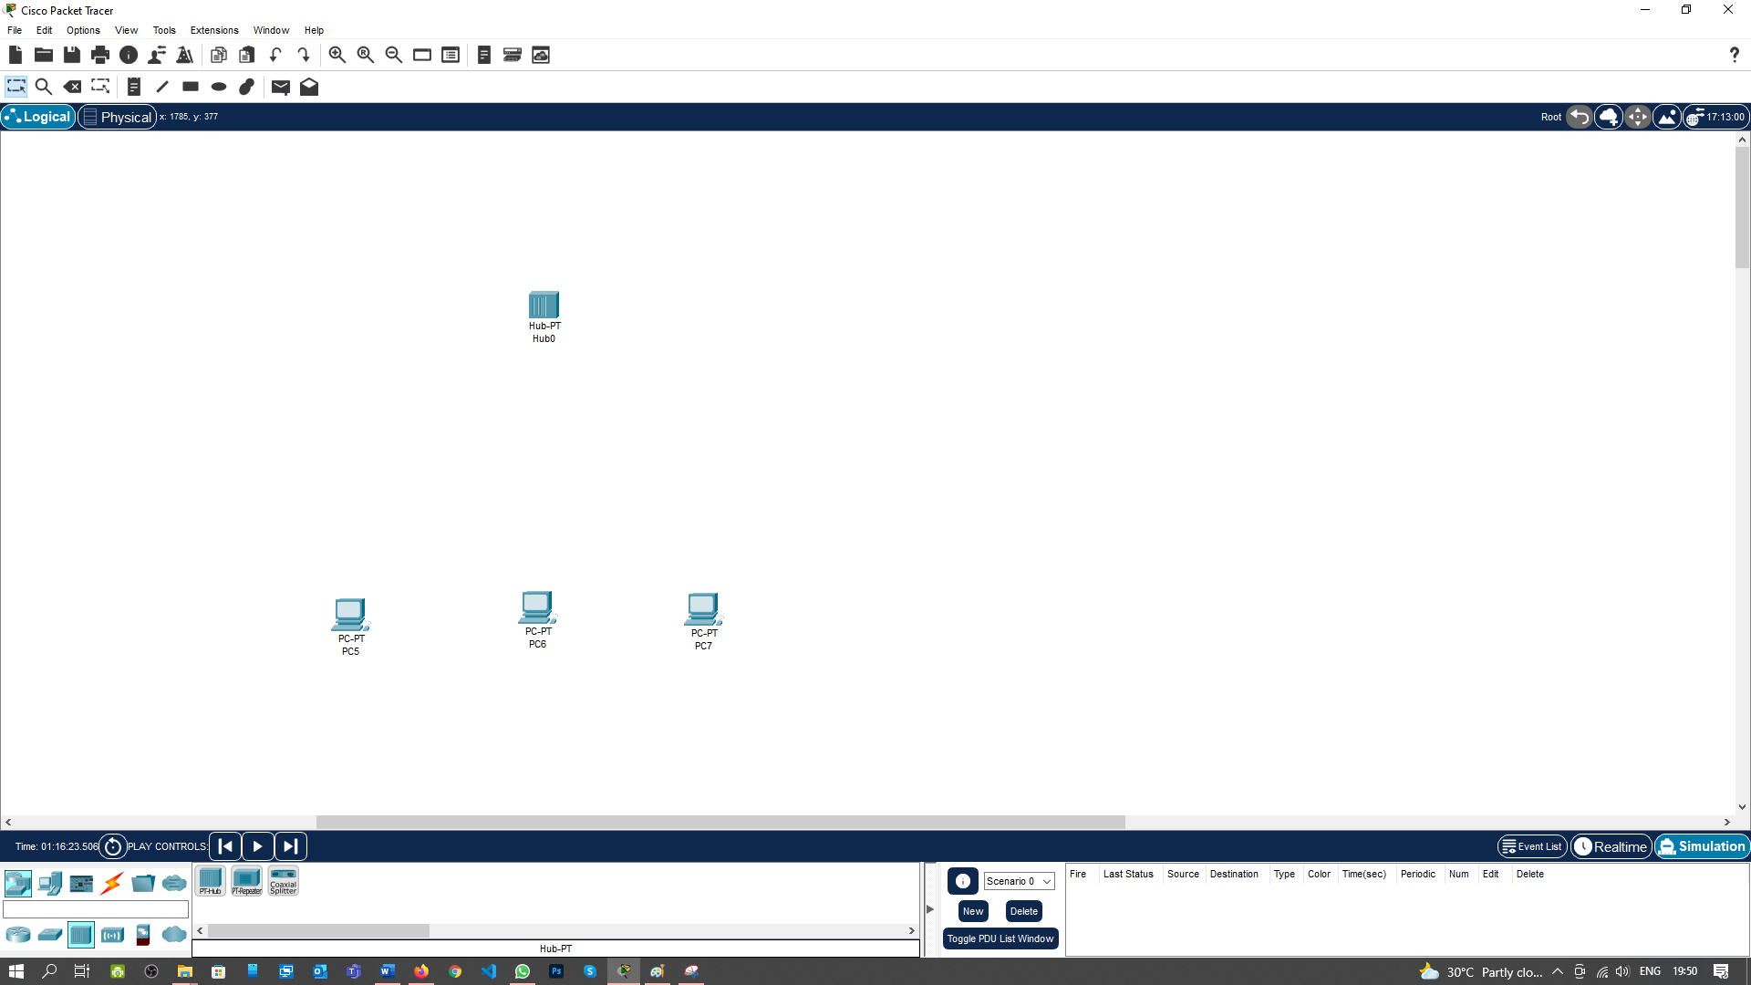

**Step 3:** Now to select the Connections from bottom bar and select the Couper Straight-Through wire.

Bottom toolbar-> Connections -> Couper Straight-Through

This is how it will appear on the screen

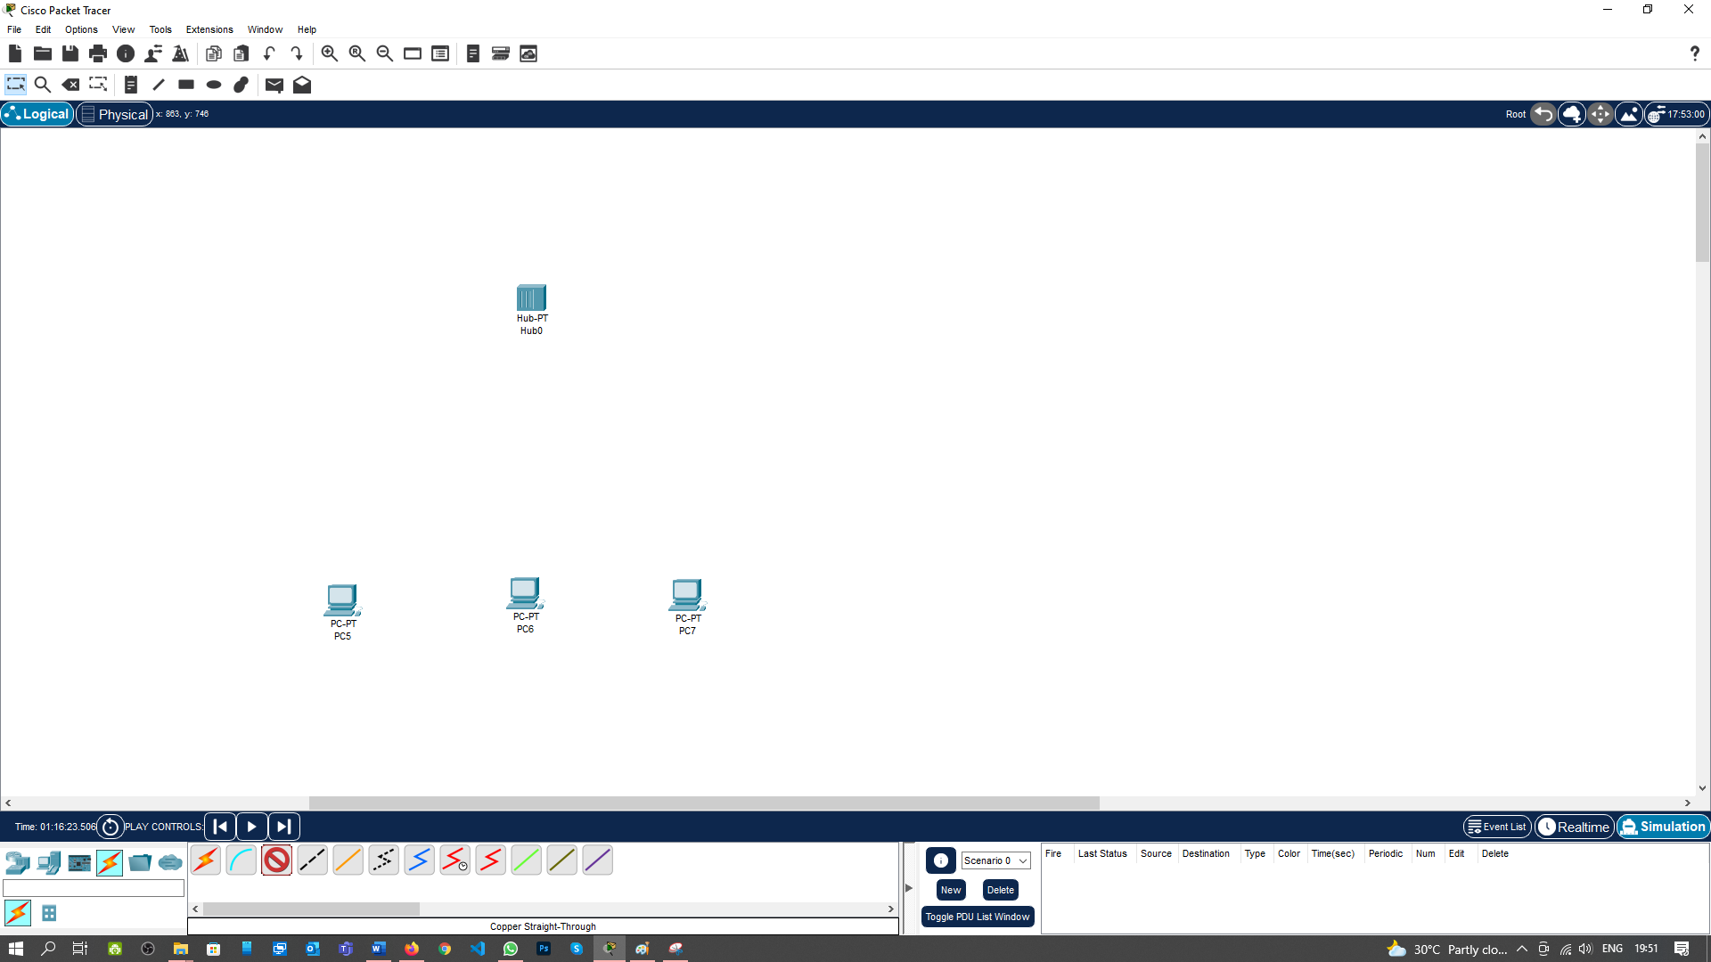

**Step 4:** Now to select the PC 0 you will get the Popup for the port then select the FastEthernet0.

Select PC 0 -> FastEthernet0

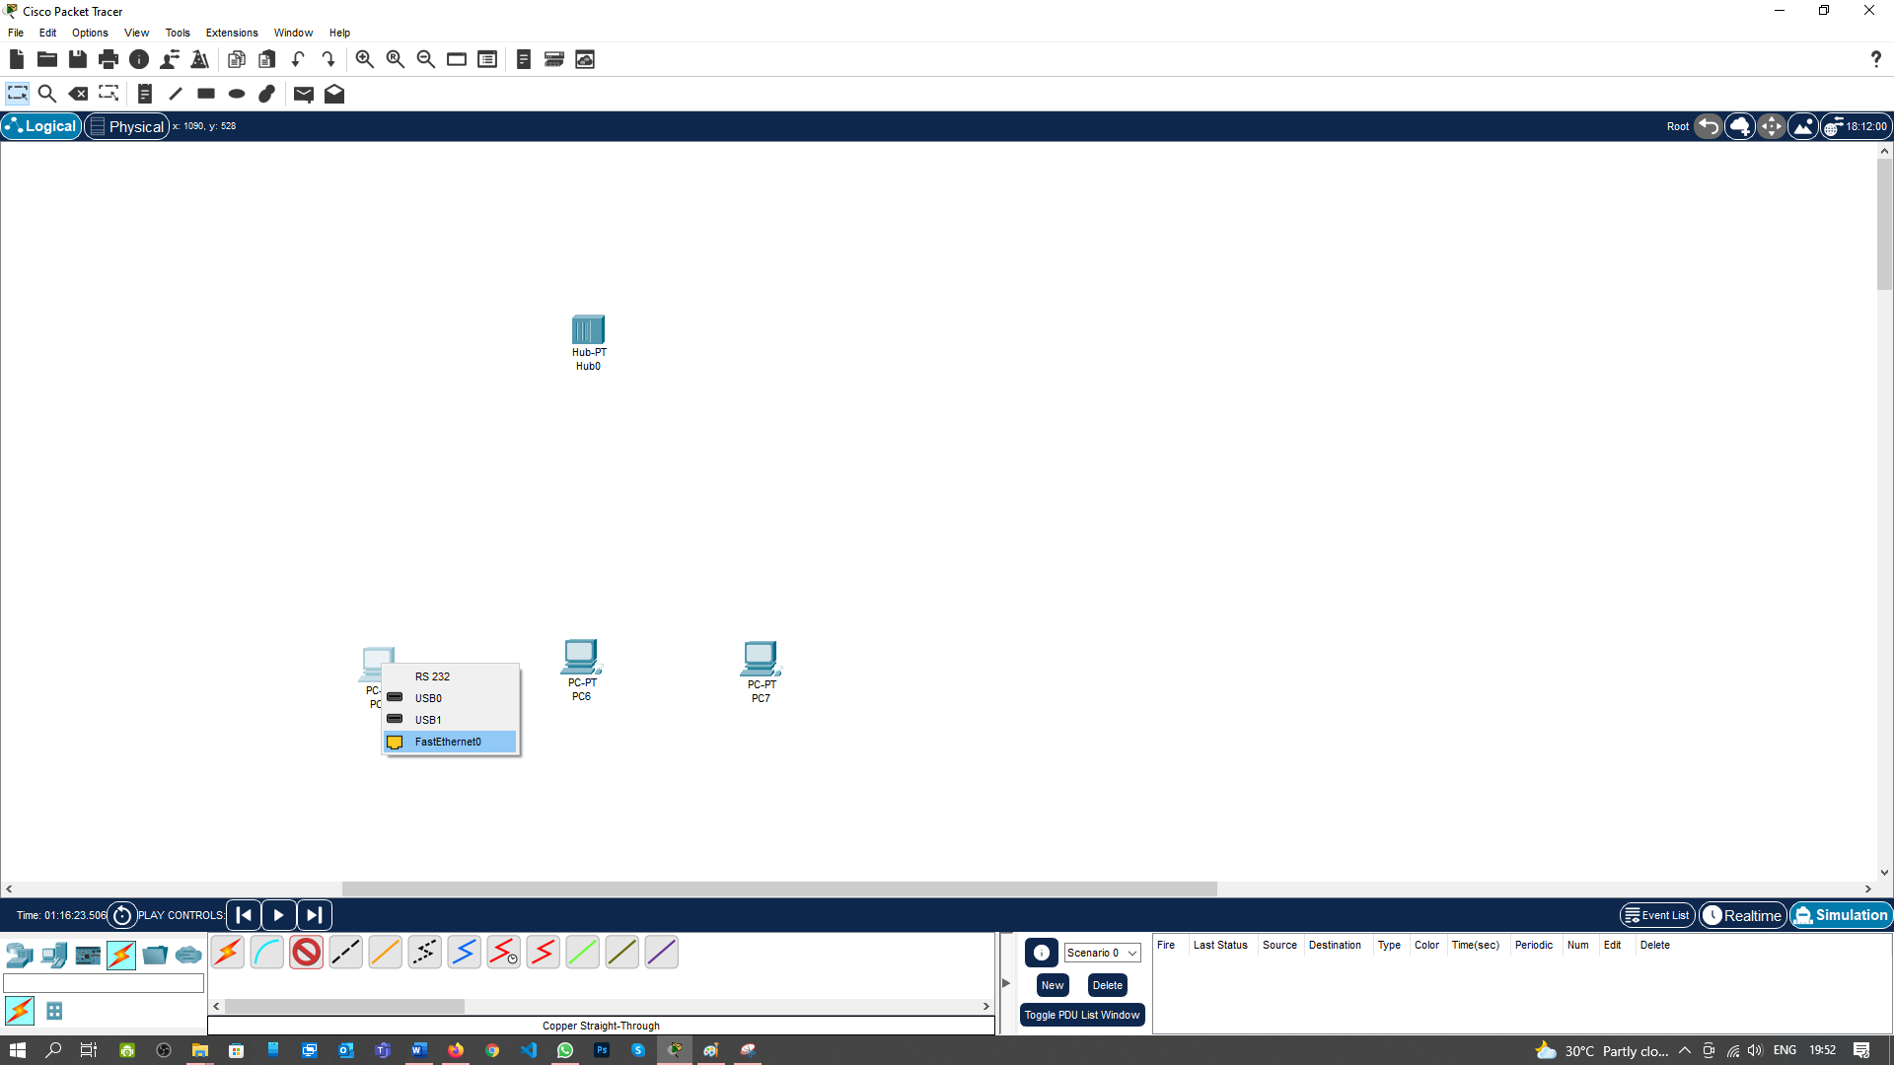

**Step 5:** Now click on the Hub you will get the Popup for the port then select the FastEthernet0 or Available Fast Ethernet port.

Select Hub -> FastEthernet0

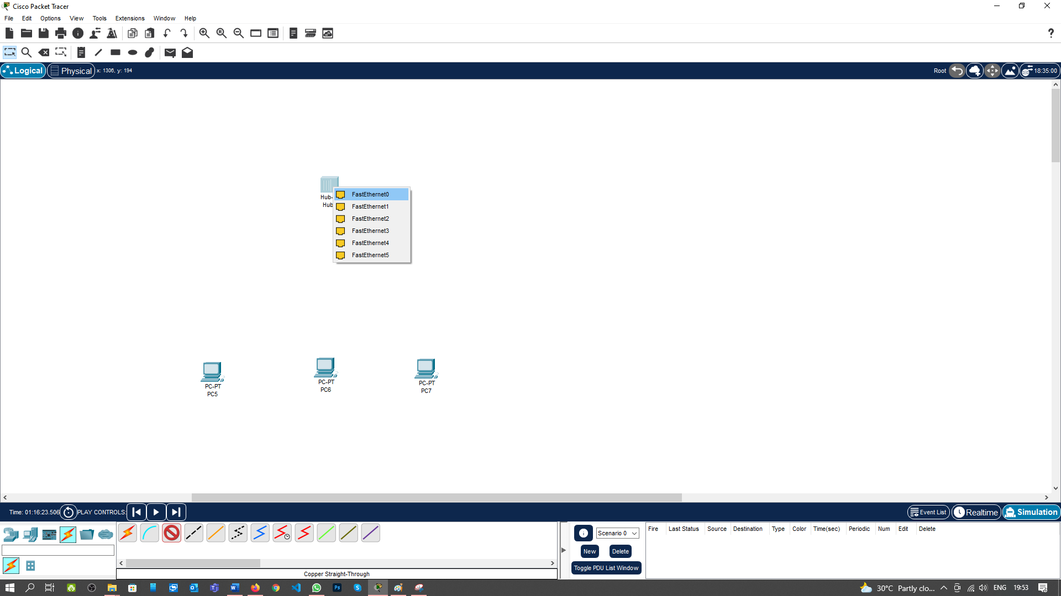

Now the Screen will be appeared Like this

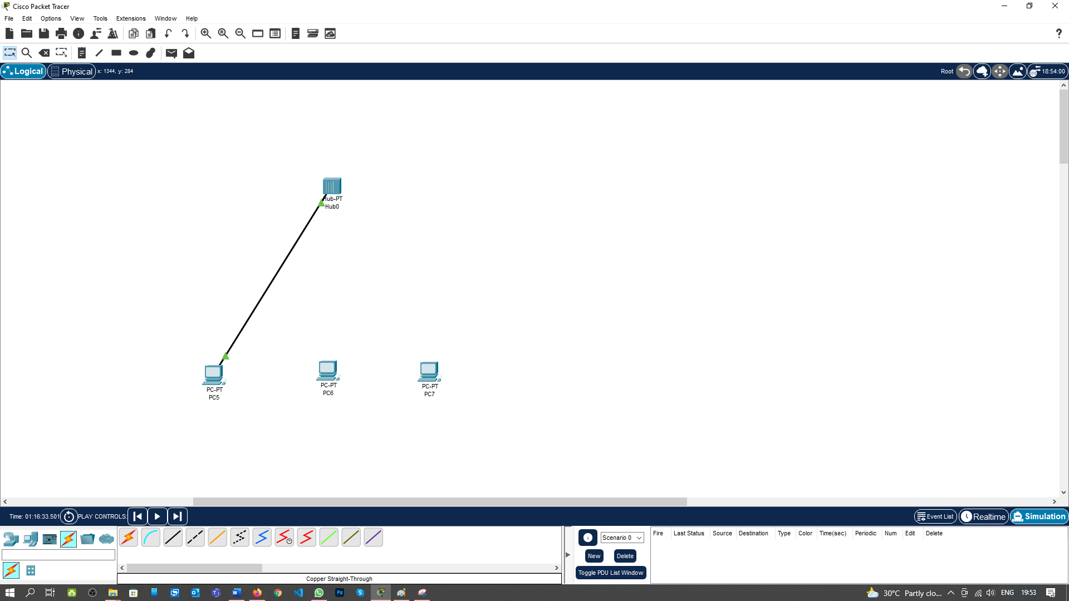

**Step 6:** Repeat the step 3 to 5 for all the PC1 and PC2

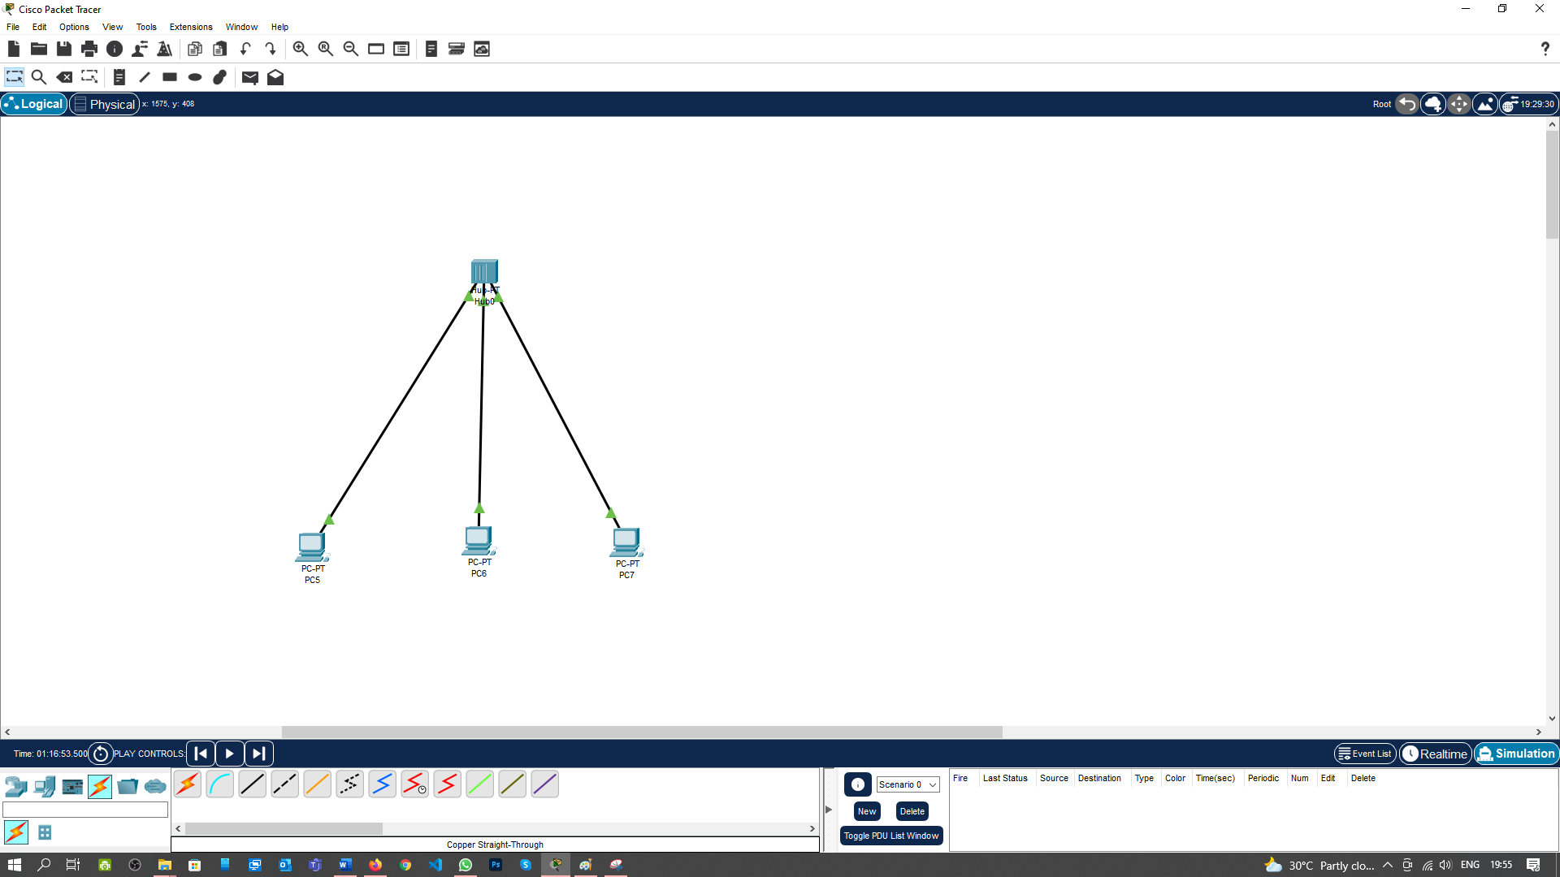

**Now, we will assign the IP address to all three PCs (PC0, PC1 & PC2).**

**Step 7: Click on the PC0 then on new window will open for Configuring the PCs.**



**Step 8:** Select the Desktop.



**Step 9:** Select the IP Configuration.



**Step 10:** Type the IP Address 192.168.1.1 and click on the Subnet Mask fields. It will accept automatically.



**Step 11:** Repeat the Step 7 to Step 10 for PC1 & PC2 with the IP Address 192.168.1.2 & 192.168.1.3 respectively.

**Now our all the Connection is done for Communication Using Hub.**

**Step 12:** To check the connection of the PCs Just Go to the Desktop and Click on the Command prompt of the PC0 and type the Ping Command along with the IP Address of PC2.

Click on PC0->Desktop->Command Prompt



**Step 13:** Select the **Add Simple PDU** from the Task bar and Then selct the PC0 first then Select the PC2 you will see the **RunTime**  Successful message uin The Bottom bar.

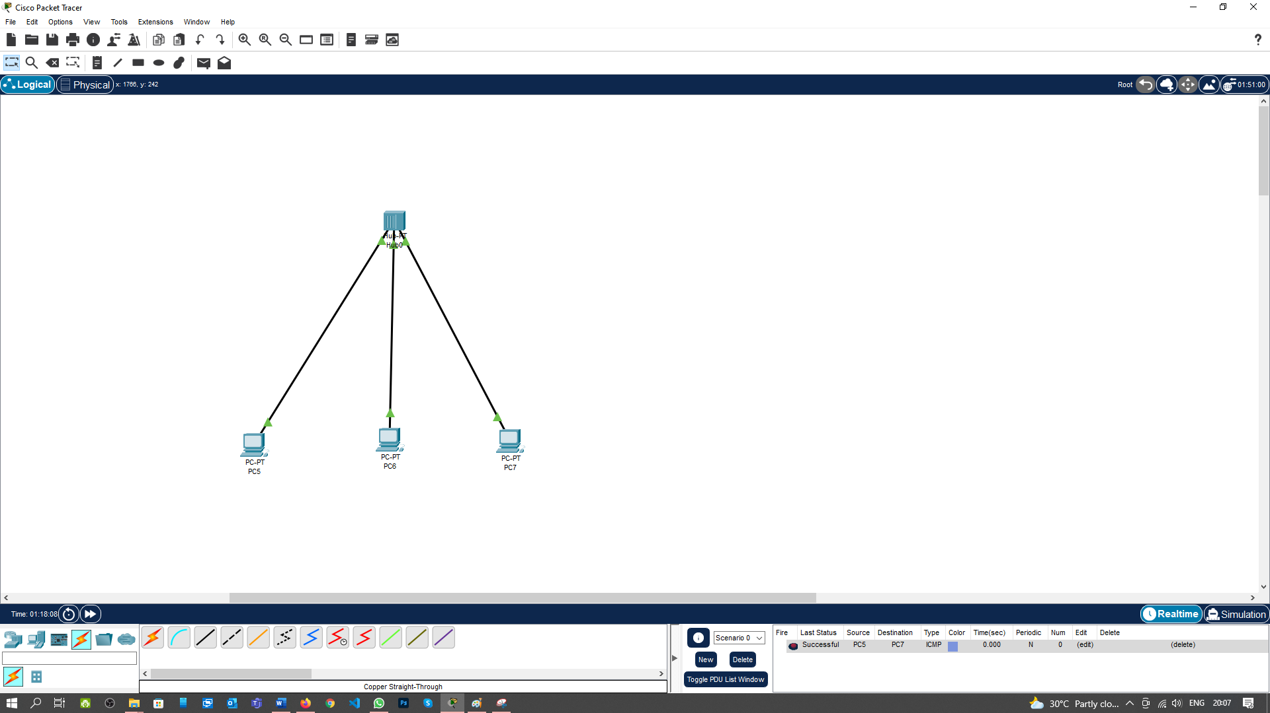

**Step 13:** Now select the Simulation Mode from the Bottom Bar and then Click Paly.You will Absorb the Steps of message transfer from PC0 to PC2 which is shown in the Below Screenshot.

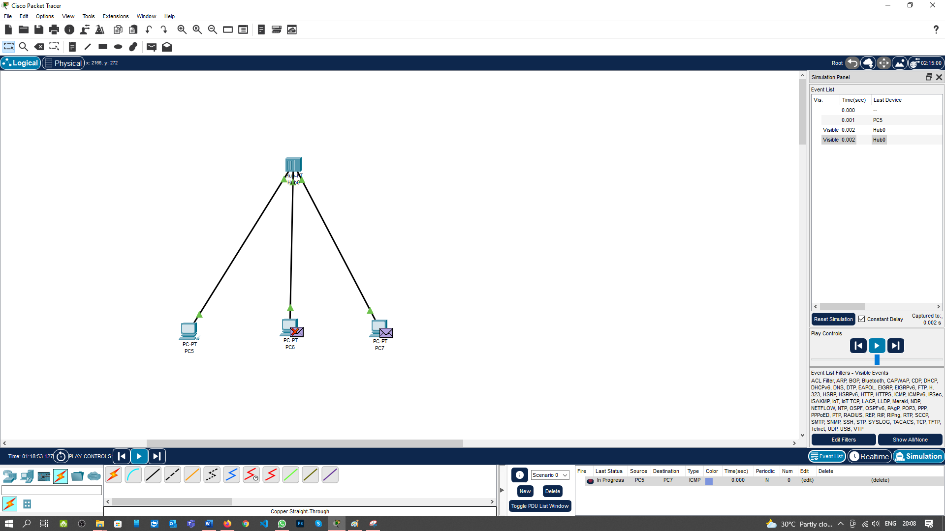

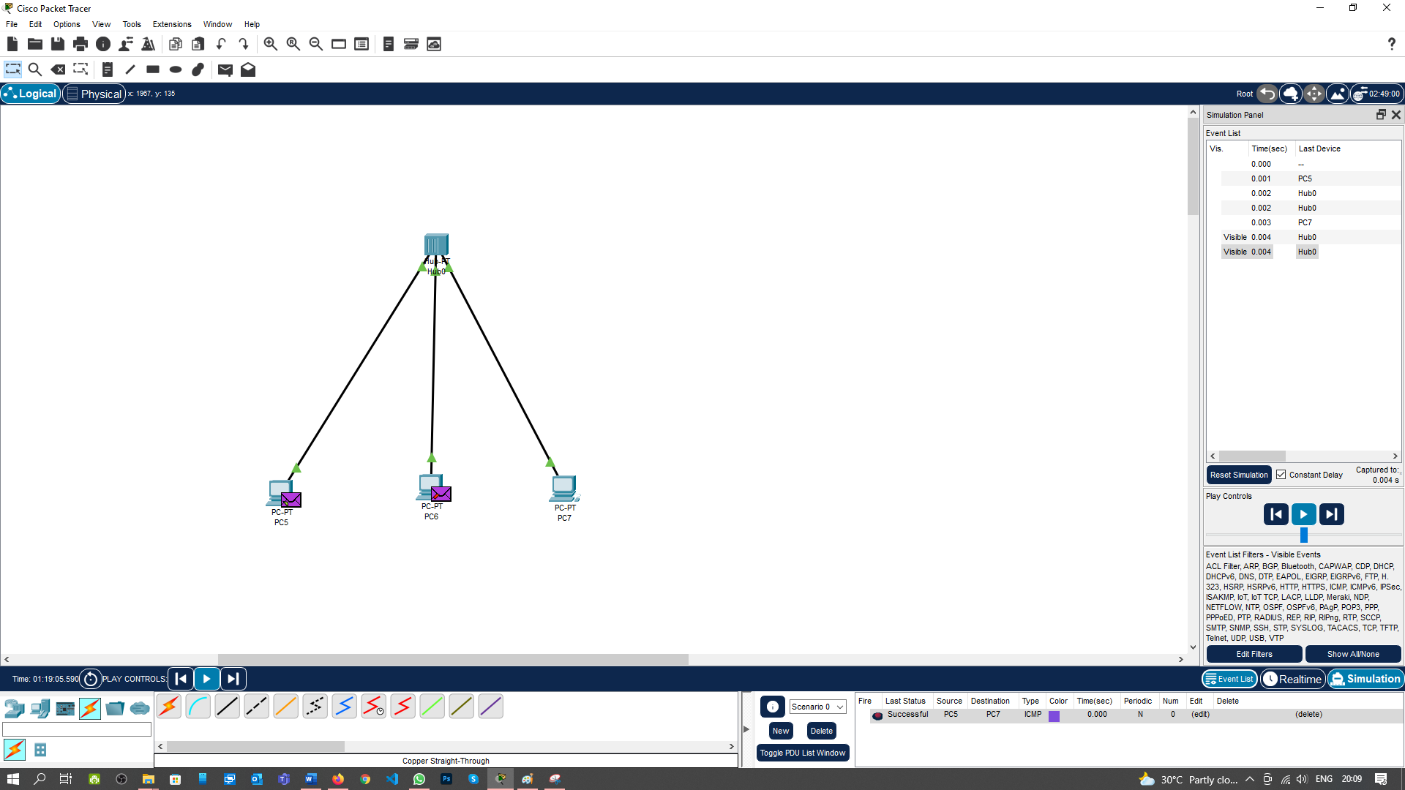

I have successfully connected three computers, using Switch and Hub in the virtual program Cisco Packet Tracer.

**Learning outcomes (What I have learnt):**

**1.** Understand working of network devices

**2.** Executed all type of networking device connections

**Evaluation Grid (To be created as per the SOP and Assessment guidelines by the faculty):**

|  |  |  |  |
| --- | --- | --- | --- |
| Sr. No. | Parameters | Marks Obtained | Maximum Marks |
| 1. |  |  |  |
| 2. |  |  |  |
| 3. |  |  |  |
|  |  |  |  |